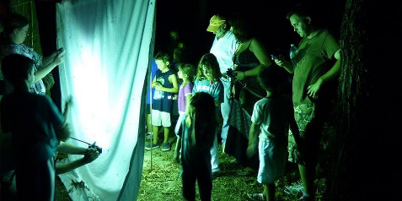

[Mothapalooza at White Sands National Monument](https://www.alamogordonews.com/story/news/local/new-mexico/2017/07/29/white-sands-national-monuments-hosts-mothapalooza/523036001/)

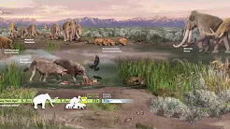

[Geology Ranger Minute](https://www.youtube.com/watch?v=KMswVC4nqgk)

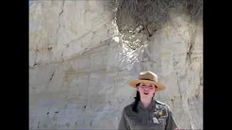

[Plant Pedestals](https://www.youtube.com/watch?v=skIE4TDUnTA)

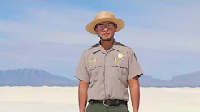

[Water and Wind](https://www.youtube.com/watch?v=LjqtfzeQ0nI)

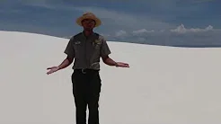

[Cradle of Life](https://www.youtube.com/watch?v=90mfSmFsKxM)

White Sands

National

Monument

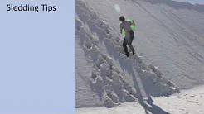

[Sledding In the Dunes](https://www.youtube.com/watch?v=jthzyu6TmR8)

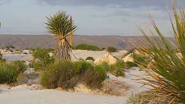

[A Spanish/English Bilingual Video](https://www.youtube.com/watch?v=Qh4Rn6g8fjA)

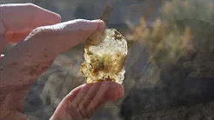

[Lake Lucero](https://www.youtube.com/watch?v=DwSCDVI9MYY)

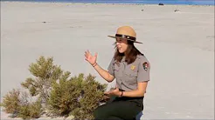

[Pickleweed](https://www.youtube.com/watch?v=k8mgROhXpPk)

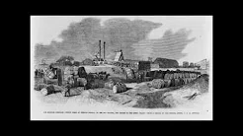

[Historic Adobe Buildings in White Sands National Monument](https://www.youtube.com/watch?v=t1idioE6-ws)