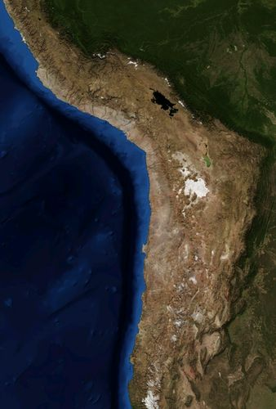

[Desert Racing](https://www.readworks.org/article/Desert-Racing/accca090-eb1c-4a20-8193-f4069377ae7b#!articleTab:content/)

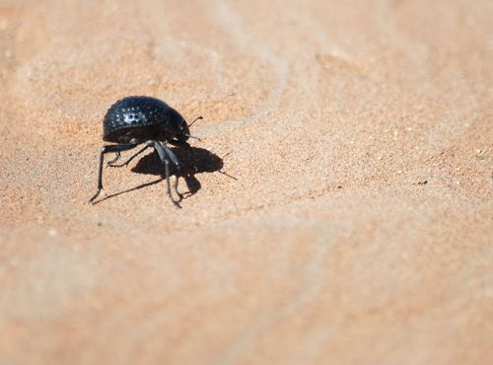

[Namib Desert Beetle](https://www.readworks.org/article/Examples-of-Biomimicry/d65d3c7b-ba76-4569-bd23-7bc077fcf709#!articleTab:content/contentSection:26e4790f-d92e-4de7-8d8e-6ac6c09fc302/)

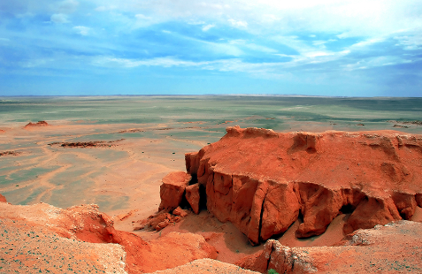

[Where Is the Gobi Desert?](https://wonderopolis.org/wonder/where-is-the-gobi-desert)

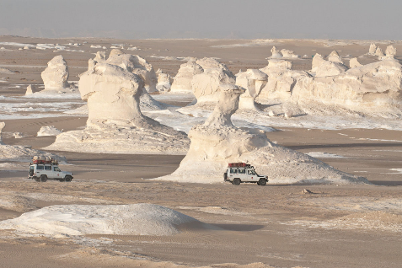

[White Desert: Non Fiction](https://www.atlasobscura.com/places/white-desert)

Deserts

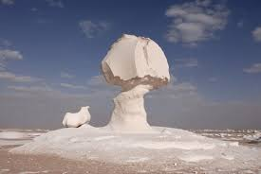

[The White Desert: A Fiction Story](https://www.readworks.org/article/The-White-Desert/97081926-75ce-48d9-b4b7-39786d52affb#!articleTab:content/)

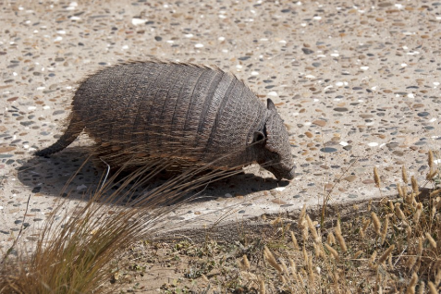

[Where Do Armadillos Live?](https://wonderopolis.org/wonder/where-do-armadillos-live)

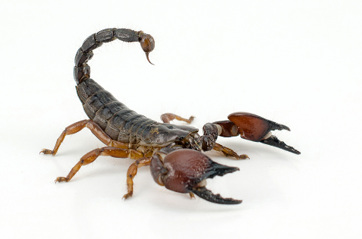

[Are Scorpions Deadly?](https://wonderopolis.org/wonder/are-scorpions-deadly)

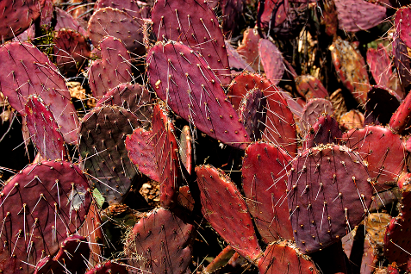

[How Does a Cactus Live Without Water](https://wonderopolis.org/wonder/how-does-a-cactus-live-without-water)